Annual

Report

  - 2019
TC43 : “Our Journey Continues…”

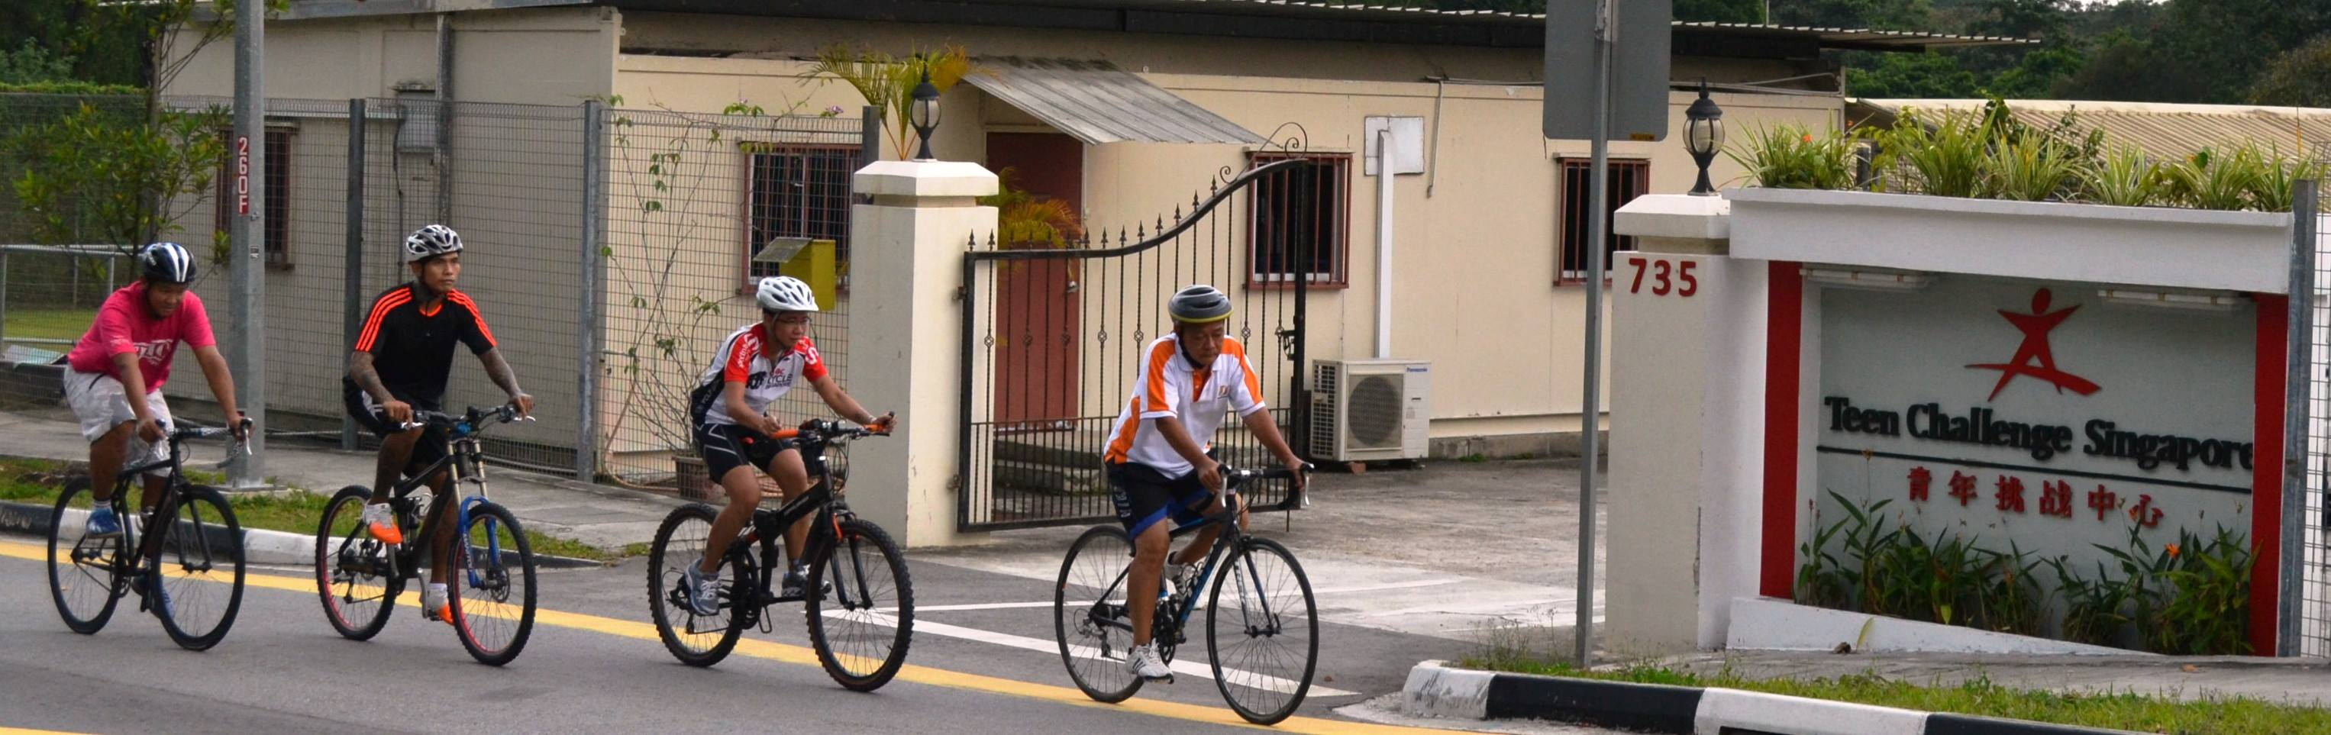
Tel: 6793 7933 | 735 Old Choa Chu Kang Road Singapore 699798 | Email: info@teenchallenge.org.sg | www.teenchallenge.org.sg

Contents

Introduction 3

President’s Message 4

Executive Director’s Message 5

Review of Year 2019 6

Financial Statements 8

Introduction

Teen Challenge (Singapore) was pioneered in October 1976 by Rev Naomi Dowdy, under the auspices of the Assemblies of God.

Teen Challenge (Singapore) was registered as a Society on 14 April 1987.

Unique Entity Number : S87SS0001D

Registered Address : 735 Old Choa Chu Kang Road
Singapore 699798

Banker : DBS Bank

Auditor : Baker Tilly TFW LLP

Executive Director : Luke Tan

President’s Message | 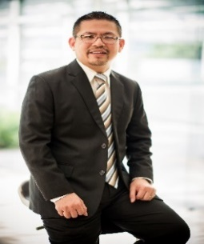
I would like to start off by thanking all of you for your support and participation in 2019, for making Teen Challenge a special place! It has truly been a fulfilling year to witness the lives impacted thru our various programs.

We have renewed our partnership with Singapore Prisons under the Halfway House Service Model (HSM). Our Drug and Alcohol Recovery Centre continues to be the forefront of our work and ministry. We had a total of 41 admissions last year, 37 from prison, 1 walk in and 3 under the Residential aftercare support program.

Under of Pastoral Care and Outreach, we train our volunteers well so as to equip them with skills and knowledge to provide in care services to inmates within Cluster A, B & C of Changi Prison, Tanah Merah Prison and Lloyd Leas Community Supervision Centre. Between them, the volunteers contributed at total of over 4800 hours of service and in the process lifted the spirits of over 500 lives.

We are also grateful for the continued support and contribution from many of our long-time partners consisting of churches, companies, organisations, schools and individuals. We have also seen new partners come on board. These partners have given precious time and resources to Teen Challenge.

As we look ahead, we remain committed to our vision of seeing recovering individuals restored to wholeness. We remain committed in equipping and empowering every person that walks thru the doors of Teen Challenge to become a contributing individual thru our faith based therapeutic program.

Finally, my deepest appreciation to our Board, our staffs and volunteers that has worked so tirelessly to support the life, vision and mission of Teen Challenge. We are grateful for your outstanding commitment and passion.

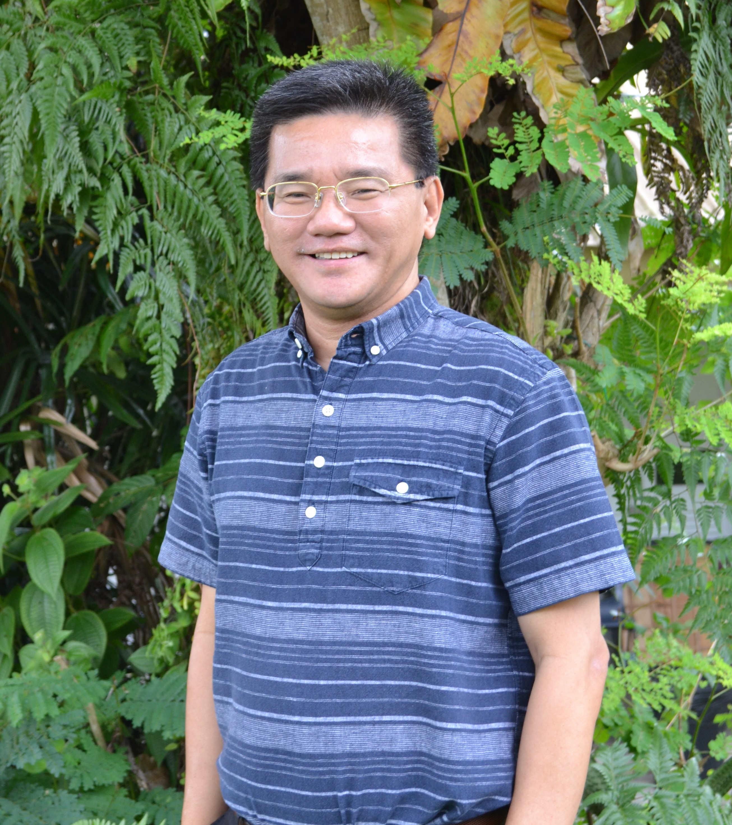

Executive Director’s Message

2019 was the bicentennial year for Singapore, a much celebrated milestone for our progress as a nation since her founding in 1819. It also has been 43 years since Teen Challenge commenced the ministry of recovery and rehabilitation to those struggling with drug addiction. We have positioned and privileged to touch and transform lives of thousands over the years.
TC has thrived and grown over the days. The recovery work would not have been possible without the generous and continual financial contributions from many individuals, churches, corporate partners and support from our government. We are thankful to God and to each of you for all these provisions.
TC remains a strong partner with Singapore Prison Service in this collective effort to see ex-offenders and drug users restored to wholeness. We are a member of United Against Drugs Coalition, an initiative launched by Central Narcotics Bureau on 25 April 2017.

Our Drug and Alcohol Recovery Centre received a total of 41 admissions into the residential programme in 2019. The majority of the residents were from prison under the Community Based Programme and the rest were walk in clients. Our objective is to prepare and integrate our beneficiaries back to society as useful and contributing members.

The residential facility in 735 Old Choa Chu Kang undergone a long overdue Cyclical Maintenance. It began in April and completed in August. This old former primary school which was more than half a century old is given a new lease of life. The buildings and its roofing were given a fresh coat of paint. The broken and clogged drainages were repaired. It is refreshing for this facility which TC has occupied close to 3 decades.

Singapore’s Bicentennial Year also opens up new fund opportunity for all Social Service Agencies. As an Institution of Public Character, we are thankful that through the Bicentennial Community Fund, TC is looking forward to receive a matching grant of $400,000 next year.

We do not know what the future and 2020 have in store for everyone. But one thing is for sure, this additional funding will help our recovery work in a big way. Someone once said: “Kindness makes you the most beautiful person in the world, no matter what you look like.” Thank you for gift of love.

Review of Year 2019

STAFFING

As at 31.12.2019, Teen Challenge Singapore has 20 permanent full-time staff.

ACTIVITIES

Drug & Alcohol Recovery (DARE) Centre has the capacity to house up to 60 residents. In 2019, DARE Centre received 41 admissions into the residential programme. Out of these 41 individuals, 37 came from Prison under the Community Based Programme (CBP), 3 of them sought transitional accommodation under the Residential Aftercare Support Programme (RASP) and the remaining 1 person was a Walk-In client into the Centre. A total of 37 individuals successfully completed their programme.

Residents from Prison served out their remaining sentences in the Centre, typically between six months to one year. During the residency period, TC Staff and Casework team journeyed with the clients to help them build circles of community support, develop life-skills through Spiritual and Social programme to inculcate a positive lifestyle and life after their programme.

TC as a faith based recovery centre continues to place its emphasis on encouraging all residents to know and discover the power of God to change life. Some residents eventually made their own decisions be followers of Christ and live out transformed lives.

TC is an advocate for alternative sentencing. We receive into our residential care programme individuals who have been placed under court-mandated probation or community service programme.

As part of the Recovery programme, residents in TC Dare Centre also participated in the following activities:

- Community Sports Event
- Annual “Yellow Ribbon Run” on 15 September

- Spiritual Emphasis Event
- Weekly attendance at Chapel Service & Worship Services in various Churches
- Volunteered as Car Park Marshals at the Jana Alayra Worship Concert 2019 on 7 & 8 November

Pastoral Care and Outreach Department conducted In-Care programmes to incarcerated individuals through its pool of 50 active volunteers. TC volunteers carried out weekly programmes within the Clusters A, B & C of Changi Prison Complex and Lloyd Leas Community Supervision Centre.
Our dedicated volunteers conduct Chapel Service, Bible Study, Individual Counselling sessions, Motivational Talk, 12 Steps, Mentoring, Enrichment, Desistor, Befriending and Aftercare programmes to hundreds of inmates, registering an estimated total of 4800 volunteer hours.

Teen Challenge Enterprises Ltd is a member of Singapore Centre for Social Enterprise (raiSE) since 2015. TC Enterprises (TC Mover, TC WoodWork and TC Gift) provide skill development training and employment opportunities to residents undergoing the rehabilitation programme in the Centre.

The entire staff and team members in TC Enterprises were former residents of the halfway house. Besides generating revenues to sustain the social enterprises, what is often unknown is the Social Return of Investment (SROI). This Social ROI can be seen through the lives of our beneficiaries who have been transformed and are becoming useful contributing members of our society.

Fund Raising Event and Activity
Teen Challenge organized 4 fund raising activities in 2019. These were Pledge Card Donation Drive throughout the month of May to the end of July, the 19th Teen Challenge Charity Golf Fund Raising event on 27 September, the 7 a-side Football Tournament on 16 November and a Movie Premiere event on 20 December.
The primary fundraising raising platform is the annual Charity Golf event which took place in Tanah Merah Country Club. There were 136 participants and close to $190,000 was raised. Contributions to Teen Challenge Singapore derived mainly from government grants, other Organizations, Companies, Churches and many Individuals.

